European T+1 Industry Task Force publishes Roadmap for Adoption of T+1 in EU securities markets

“The European T+1 Industry Task Force has today published a report outlining its preliminary analysis on the regulatory, technical, and operational changes required to facilitate a successful transition to T+1 in EU securities markets.
The Task Force is supportive of the EU moving to T+1, and promotes a coordinated approach with key regional partners including the UK and Switzerland.
The report highlights that a successful transition requires further industry focus on improving the efficiency of existing post-trade processes.
There is clear consensus that September-October is the optimal period for the move to take effect, with a 24-36 month transition period envisaged.
As a next step, the Task Force calls for EU public authorities to make a formal commitment to moving to T+1, and provide a mandate for a broad industry stakeholder group to take forward the next phase of work. The Task Force is fully committed to supporting the next phase of work.”

About the European T+1 Task Force:
The Task Force was established in 2023, to bring together a diverse group of industry stakeholders who would be impacted by a potential move to a default T+1 securities settlement cycle. The Task Force contains representation from industry associations representing all types of market participant, including buy-side, sell-side and market infrastructures.
To date, the Task Force has conducted analysis on the potential impacts and challenges for European players from the North American migration to T+1 taking place in May 2024 and some initial factfinding across different subgroups about impacts of a potential EU move to T+1 in anticipation of ESMA’s work. The Task Force also submitted a joint statement in response to the ESMA Call for Evidence on Shortening the Settlement Cycle in December 2023.
The Task Force is open to participation from any industry association representing securities market participants who would be impacted by T+1. Interested parties are invited to contact peter.tomlinson@afme.eu

Participating Associations
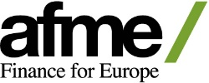 | AFME represents a broad array of European and global participants in the wholesale financial markets. Its members comprise pan-EU and global banks as well as key regional banks, brokers, law firms, investors and other financial market participants. We advocate stable, competitive, sustainable European financial markets that support economic growth and benefit society.  AFME is the European member of the Global Financial Markets Association (GFMA) a global alliance with the Securities Industry and Financial Markets Association (SIFMA) in the US, and the Asia Securities Industry and Financial Markets Association (ASIFMA) in Asia.  AFME is registered on the EU Transparency Register, registration number 65110063986-76.
 | The Alternative Investment Management Association (AIMA) is the global representative of the alternative investment industry, with around 2,100 corporate members in over 60 countries. AIMA’s fund manager members collectively manage more than US$3 trillion in hedge fund and private credit assets.  AIMA draws upon the expertise and diversity of its membership to provide leadership in industry initiatives such as advocacy, policy and regulatory engagement, educational programmes and sound practice guides. AIMA works to raise media and public awareness of the value of the industry.  AIMA set up the Alternative Credit Council (ACC) to help firms focused in the private credit and direct lending space. The ACC currently represents over 250 members that manage over US$1 trillion of private credit assets globally.  AIMA is committed to developing skills and education standards and is a co-founder of the Chartered Alternative Investment Analyst designation (CAIA) – the first and only specialised educational standard for alternative investment specialists. AIMA is governed by its Council (Board of Directors).
 | Established in 1996, the Association of Global Custodians (the “Association”) is a group of 12 global financial institutions that each provides securities custody and asset-servicing functions primarily to institutional cross-border investors worldwide. As a non-partisan advocacy organization, the Association represents members’ common interests on regulatory and market structure. The member banks are competitors, and the Association does not involve itself in member commercial activities or take positions concerning how members should conduct their custody and related businesses.  The members of the Association are: BNP Paribas; BNY; Brown Brothers Harriman & Co; Citibank, N.A.; Deutsche Bank; HSBC Securities Services; JP Morgan; Northern Trust; RBC Investor & Treasury Services; Skandinaviska Enskilda Banken; Standard Chartered Bank; and State Street Bank and Trust Company.
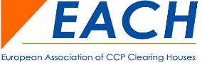 | The European Association of CCP Clearing Houses (EACH) represents the interests of Central Counterparties (CCPs) in Europe since 1992. CCPs are financial market infrastructures that significantly contribute to safer, more efficient and transparent global financial markets. EACH currently has 18 members from 14 different European countries. EACH is registered in the European Union Transparency Register with number 36897011311-96.
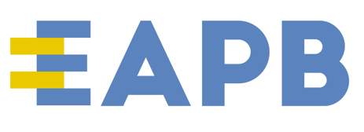 | The EAPB is the voice of the European public banking sector. It represents directly and indirectly over 90 financial institutions with overall total assets of over € 3.500 bn and 15% market share of the European financial sector. EAPB members are national and regional promotional banks, municipality funding agencies and public commercial banks across Europe.
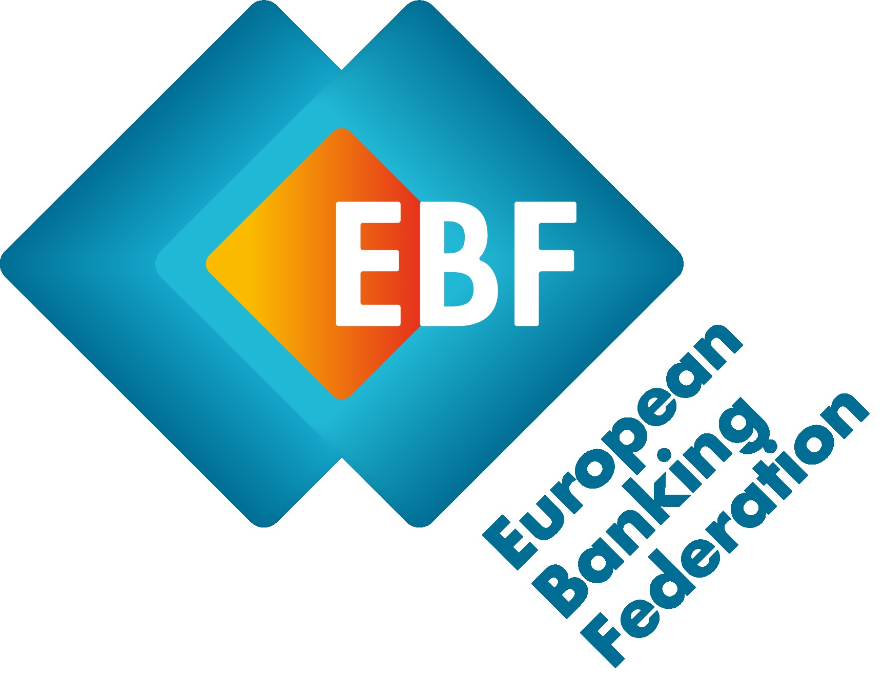 | The European Banking Federation is the voice of the European banking sector, uniting 33 national banking associations in Europe that together represent some 3,500 banks – large and small, wholesale and retail, local and international – employing about 2,7 million people.
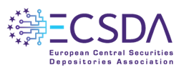 | The European Central Securities Depositories Association (ECSDA) represents 40 national and international central securities depositories (CSDs) across 36 European countries. The association provides a forum for European CSDs to exchange views and take forward projects of mutual interest. It aims to promote a constructive dialogue between the CSD community, European public authorities, and other stakeholders aiming at contributing to an efficient and risk-averse infrastructure for European financial markets.
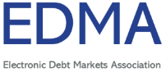 | Electronic Debt Markets Association (EDMA) represents the common interests of companies whose primary business is the operation of regulated electronic fixed income trading venues (multilateral trading facilities and regulated markets) in Europe. EDMA seeks to foster and promote liquid, transparent, safe and fair markets and act as the voice and a source of consultation between the members in their roles as operators of such venues. EDMA projects collective views on regulatory matters and market structure topics to governments, policy makers and regulators for the benefit of the electronic fixed income markets.
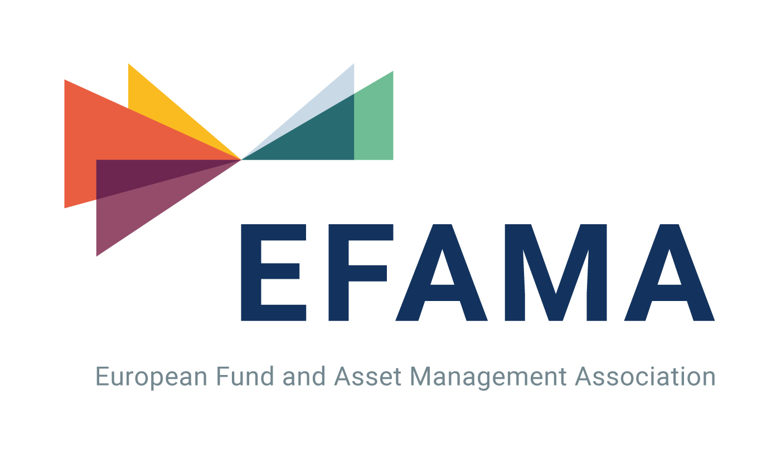 | EFAMA is the voice of the European investment management industry, which manages over EUR 30 trillion of assets on behalf of its clients in Europe and around the world. We advocate for a regulatory environment that supports our industry’s crucial role in steering capital towards investments for a sustainable future and providing long-term value for investors.  Besides fostering a Capital Markets Union, consumer empowerment and sustainable finance in Europe, we also support open and well-functioning global capital markets and engage with international standard setters and relevant third-country authorities. EFAMA is a primary source of industry statistical data and issues regular publications, including Market Insights and the authoritative EFAMA Fact Book.  More information is available at www.efama.org
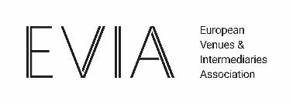 | The European Venues and Intermediaries Association promotes and enhances the value and competitiveness of Wholesale Market Venues, Platforms and Arranging Intermediaries by providing members with co-ordination and a common voice to foster and promote liquid, transparent and fair markets.  It has built a credible reputation over 50 years, by acting as a focal point for its members when communicating with central banks, governments, policy makers, and regulators.
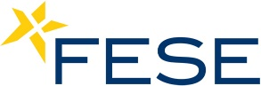 | The Federation of European Securities Exchanges (FESE) represents 36 exchanges in equities, bonds, derivatives and commodities through 17 Full Members and 1 Affiliate Member from 31 countries.  At the end of September 2024, FESE members had 6,646 companies listed on their markets, of which 19% are foreign companies contributing towards European integration and providing broad and liquid access to Europe’s capital markets. Many of our members also organise specialised markets that allow small and medium sized companies across Europe to access capital markets; 1,499 companies were listed in these specialised markets/segments in equity, increasing choice for investors and issuers. Through their RM and MTF operations, FESE members are keen to support the European Commission’s objective of creating a competitive and efficient Capital Markets Union.
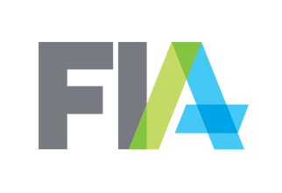 | FIA is the leading global trade organization for the futures, options and centrally cleared derivatives markets, with offices in Brussels, London, Singapore and Washington, D.C. FIA’s membership includes clearing firms, exchanges, clearinghouses, trading firms and commodities specialists from about 50 countries as well as technology vendors, law firms and other professional service providers. FIA’s mission is to:  - support open, transparent and competitive markets,  - protect and enhance the integrity of the financial system, and  - promote high standards of professional conduct.  As the principal members of derivatives clearinghouses worldwide, FIA's clearing firm members play a critical role in the reduction of systemic risk in global financial markets.
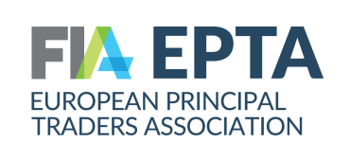 | The European Principal Traders Association (FIA EPTA) represents the leading Principal Trading Firms in the EU and UK. Our members are independent market makers and providers of liquidity and risk transfer for markets and end-investors across Europe, providing liquidity in all centrally cleared asset classes including shares, bonds, derivatives and ETFs. FIA EPTA works constructively with policymakers, regulators and other market stakeholders to ensure efficient, resilient and trusted financial markets in Europe. More information about FIA EPTA and independent market makers is available on: www.fia.org/epta and www.wearemarketmakers.com
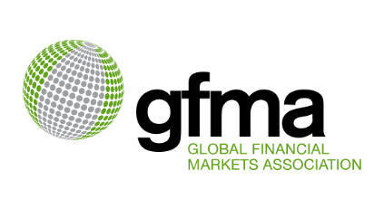 | The Global Financial Markets Association’s (GFMA) Global Foreign Exchange Division (GFXD) was formed in co-operation with the Association for Financial Markets in Europe (AFME), the Securities Industry and Financial Markets Association (SIFMA) and the Asia Securities Industry and Financial Markets Association (ASIFMA). Its members comprise 25 global foreign exchange (FX) market participants, collectively representing a significant portion of the FX inter-dealer market. Both the GFXD and its members are committed to ensuring a robust, open and fair marketplace and welcome the opportunity for continued dialogue with global regulators.
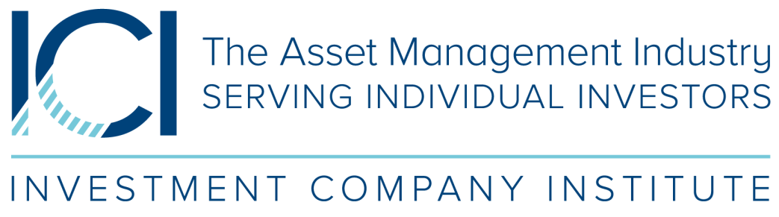 | The Investment Company Institute (ICI) is the leading association representing the global asset management industry in service of individual investors. ICI members are located in Europe, North America and Asia and manage fund assets of $45.8 trillion, including UCITS, mutual funds, exchange-traded funds (ETFs), closed-end funds, unit investment trusts (UITs) and similar funds in these different jurisdictions. ICI has offices in Brussels, London, and Washington, DC.
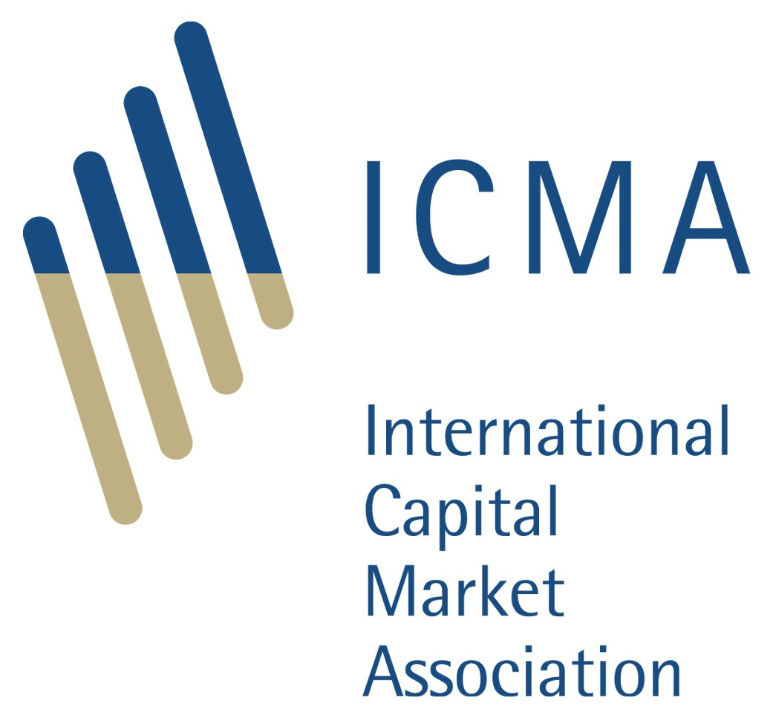 | ICMA promotes well-functioning cross-border capital markets, which are essential to fund sustainable economic growth. It is a not-for-profit membership association with offices in Zurich, London, Paris, Brussels, and Hong Kong, serving over 600 members in 66 jurisdictions globally. Its members include private and public sector issuers, banks and securities dealers, asset and fund managers, insurance companies, law firms, capital market infrastructure providers and central banks. ICMA provides industry-driven standards and recommendations, prioritising three core fixed income market areas: primary, secondary and repo and collateral, with cross-cutting themes of sustainable finance and FinTech and digitalisation. ICMA works with regulatory and governmental authorities, helping to ensure that financial regulation supports stable and efficient capital markets.
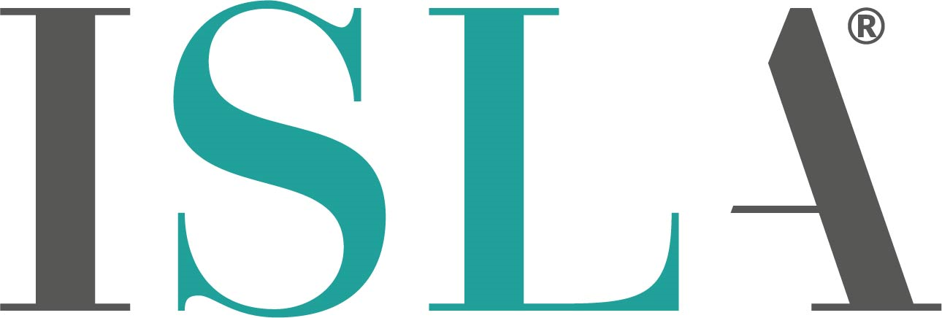 | The International Securities Lending Association (ISLA) is a leading non-profit industry association, representing the common interests of securities lending and financing market participants across Europe, Middle East and Africa. Its geographically diverse membership of over 180 firms includes institutional investors, asset managers, custodial banks, prime brokers and service providers.  Working closely with the industry, as well as national, regional, and global regulators and policy makers, ISLA advocates for, amongst other things, the importance of securities lending to the broader financial services industry. It supports both the Global Master Securities Lending Agreement (GMSLA) legal framework, including the Title Transfer and Securities Interest over Collateral variants, as well as the periodical enforceability and security enforcement across global jurisdictions.
 | ISSA is a Swiss-domiciled association that supports the securities services industry. ISSA’s members include CSDs, custodians, technology companies and other firms who are actively involved in all aspects of the securities services value chain. By connecting its members and facilitating collaboration, ISSA provides the leadership necessary to drive change in the securities services industry. The focus is on finding progressive solutions to reduce risk and improve efficiency and effectiveness – from issuer through to investor – as well as on providing broader thought-leadership to help shape the future of the industry.
Additional Observers
 | Trusted by thousands of counterparties within the global FX ecosystem, CLS makes FX safer, smoother and more cost effective. Trillions of dollars’ worth of payments flow through our systems each day.  Created by the market for the market, our unrivaled global settlement infrastructure reduces systemic risk and provides standardization for participants in many of the world’s most actively traded currencies.  Our settlement services in combination with our suite of complementary products, enable you to manage your risk most effectively across the full FX lifecycle – whether through more efficient processing tools, like CLSNet, or market intelligence derived from the largest single source of FX executed data available to the market.  More information is available at cls-group.com.
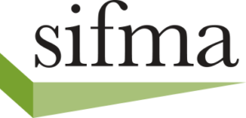 | SIFMA is the leading trade association for broker-dealers, investment banks and asset managers operating in the U.S. and global capital markets. On behalf of our industry’s one million employees, we advocate on legislation, regulation and business policy affecting retail and institutional investors, equity and fixed income markets and related products and services. We serve as an industry coordinating body to promote fair and orderly markets, informed regulatory compliance, and efficient market operations and resiliency. We also provide a forum for industry policy and professional development.  SIFMA, with offices in New York and Washington, D.C., is the U.S. regional member of the Global Financial Markets Association (GFMA).
 | Swift is a global member-owned cooperative and the world’s leading provider of secure financial messaging services. We provide our community with a platform for messaging, standards for communicating and we offer products and services to facilitate access and integration; identification, analysis and regulatory compliance.  Our messaging platform, products and services connect more than 11,500 banking and securities organisations, market infrastructures and corporate customers in more than 200 countries and territories. Whilst Swift does not hold funds or manage accounts on behalf of customers, we enable our global community of users to communicate securely, exchanging standardised financial messages in a reliable way, thereby facilitating global and local financial flows, and supporting trade and commerce all around the world.

