
EUROPEAN SMALL AND MID-CAP  INNOVATION AWARDS 2027  Application form  INTERNATIONAL STAR | 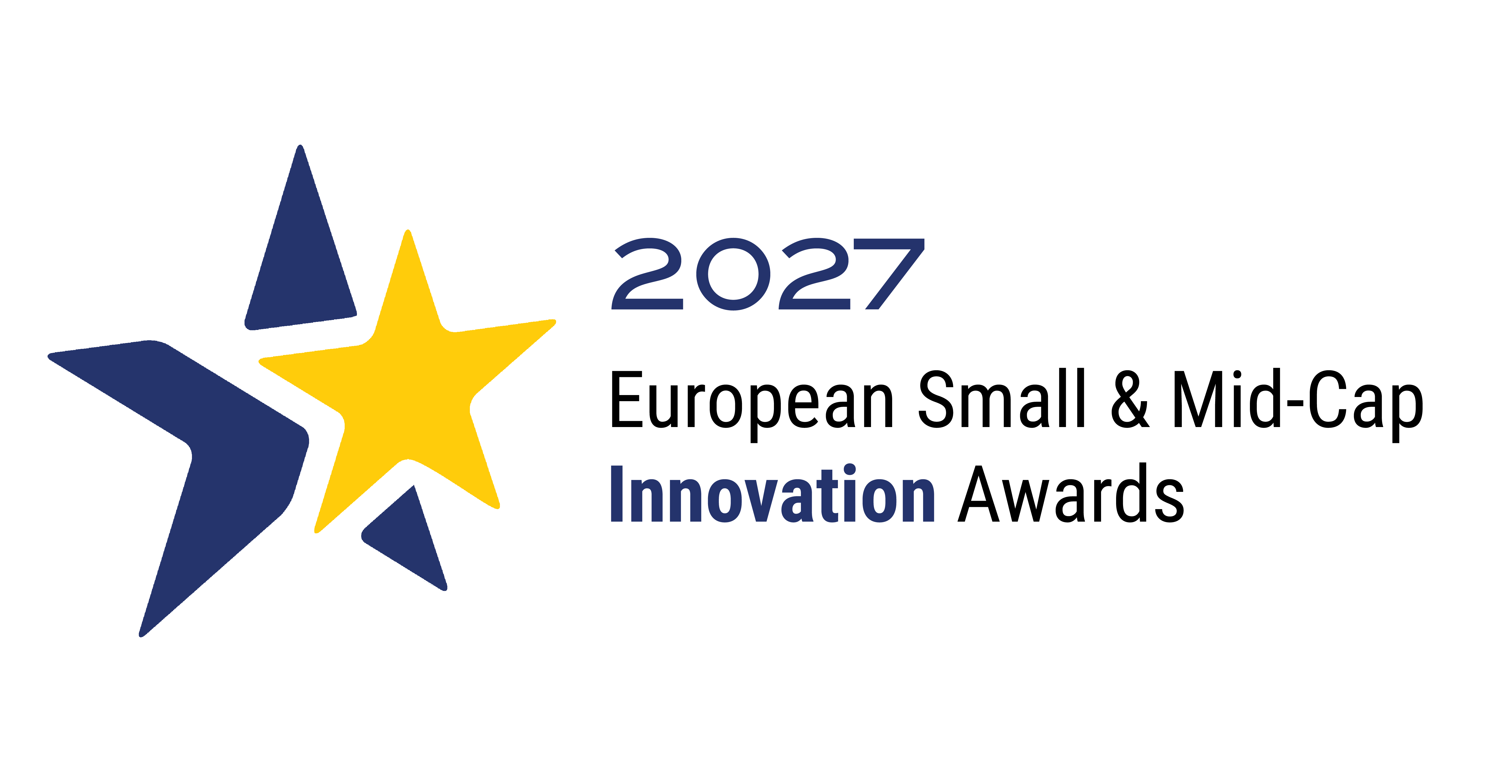
This newly listed company will have successfully expanded beyond the EU Single Market following its IPO, achieving strong results in terms of international sales, profit and market share growth. Innovation should have played a central role in enabling this expansion and strengthening the company's competitive position. The company may have expanded its presence in either existing or new markets. It will be well-managed and demonstrate a sound strategy for taking advantage of opportunities outside its own country.
TO BE COMPLETED IN ENGLISH • ALL FIELDS MANDATORY
DETAILS OF THE NOMINATING STOCK EXCHANGE
Name of exchange
Country of exchange
CONTACT PERSON
Family name
First name
Function
E-mail
Telephone number
Please provide complete phone number with country code

DETAILS OF THE NOMINATED COMPANY
Name of mid-cap
Address
Website
COMPANY CONTACT DETAILS
 | CONTACT 1 | CONTACT 2
Family name
First name
Function
E-mail
Telephone number
Please provide complete phone number with country code
COMPANY SUMMARY
Summary of mid-cap business
Listing date
Capitalisation (in EUR)

INTERNATIONALISATION Max. 1 500 characters including spaces
Please explain how the company has diversified geographically (beyond the EU Single Market) into different marketplaces, establishing a presence in and/or forging links with different markets.
- Has the company placed international operations at the heart of its business development strategy?
- Explain how the company has expanded e.g. through the establishment of subsidiaries, partnerships, or production facilities abroad, diversifying geographically into different regions and leveraging diverse resources (local talent, supply chains, technological innovations…) to strengthen its international reach?
- Does the company devote an adequate but not excessive amount to international operations and expansion, ensuring alignment with its long-term corporate goals?
Please evaluate and provide reasoning.

INNOVATION Max. 1 500 characters including spaces
Outline how the company has been innovative in terms of the product manufactured or sold, and/or service/s provided, and/or technology incorporated in the product/manufacturing process/provision of services, and/or organisational strategy.
- How has the company demonstrated true innovation in its products/services/business model?
- What makes this innovation distinctive compared to existing solutions in the market? How does it differentiate from competitors?
- How has the company's innovation contributed to its international expansion into new markets?
- Has the innovation received peer or industry recognition?
- Is the innovation protected by specific intellectual property rights?
- What are the company’s plans to sustain its competitive edge?
- Please provide some concrete results of what the innovation has achieved (such as market adoption, efficiency gains, customer benefits).
- How has the company placed innovation development at the heart of its long-term business strategy?
Please evaluate and provide reasoning.

SHARE PRICE (IN EUR) Max. 1 000 characters including spaces
Please provide quantitative figures for share price at date of flotation and compare to the data of 30.09.2026.
Has the share price appreciated steadily, providing evidence of solid long-term growth without inflation?

GROWTH Max. 1 500 characters including spaces
Please provide quantitative figures for market share, sales, employment and profit attributable to international export activity at date of floatation and compare to the same data available as of 30.09.2026.
Please also evaluate if the company built a strong position in its marketplace against global competitors from which it can develop in the future and provide reasoning for your assessment.

USE OF CAPITAL MARKETS Max. 1 500 characters including spaces
Please explain how the company has used capital markets to support its growth and development since listing.
- Has the company made use of secondary or follow-on equity issuances, debt issuance, or other forms of market-based financing? How has the capital raised contributed to the company's growth strategy, innovation, or expansion. Where possible, provide quantitative examples and evidence.
- Where no additional capital has been raised, please describe how listing has otherwise supported the company's strategic development, including enhanced visibility, access to investors, governance, credibility, partnerships, or future financing opportunities.

REPUTATION Max. 1 000 characters including spaces
Please provide supporting evidence regarding the overall reputation of the company. How is the company viewed by peers/stock-market analysts/other companies? Did it successfully adapt to local regulations, cultures, and market conditions?

CORPORATE INFORMATION Max. 500 characters including spaces
Please provide supporting evidence regarding the overall reputation of the company. How is the company viewed by peers/stock-market analysts/other companies? Did it successfully adapt to local regulations, cultures, and market conditions?

CORPORATE GOVERNANCE Max. 500 characters including spaces
Does the company behave as a good corporate citizen and provide evidence of good governance? Please evaluate and provide reasoning.

ADDITIONAL INFORMATION Max. 500 characters including spaces
Please provide any additional and relevant information to support your application.

SUPPLEMENTARY LINKS / FILES
Here you may specify up to five website links in English and upload one supporting document (less than 5 MB).
Supporting documents may include visuals and text but text will not form part of the evaluation process.
Only answers submitted above will be evaluated.

COMMENTS FROM THE STOCK EXCHANGE Max. 1 500 characters including spaces
Why was this considered to be a winning application?

Why should this application win a European Award?

